*****U*NIVERSITY OF *I*NFORMATION *T*ECHNOLOGY & *S*CIENCES (*UITS* )**

**ASSIGNMENT**

**on**

**INTERNET OF THINGS LAB**

⮘**Submitted To**⮚

***Ayanava Paul***

Lecturer,

Department of CSE, UITS

⮘**Submitted By**⮚

***F*AZLAY *R*ABBI**

* Department 🢣 CSE
* ID 🢣 2125051070
* Semester 🢣 Autumn 2024
* Batch 🢣 50
* Section 🢣 7B1
* Subject Code 🢣 CSE 402
* Date of Submission 🢣 23.09.2024

**Signature**

Analog Input- Digital Output

Title: Analog Input (Potentiometer) Digital Output (LED blink)

Necessary Equipment:

1. Arduino UNO R3
2. Breadboard
3. 330 Ohm resistor
4. 3 LED
5. Potentiometer
6. 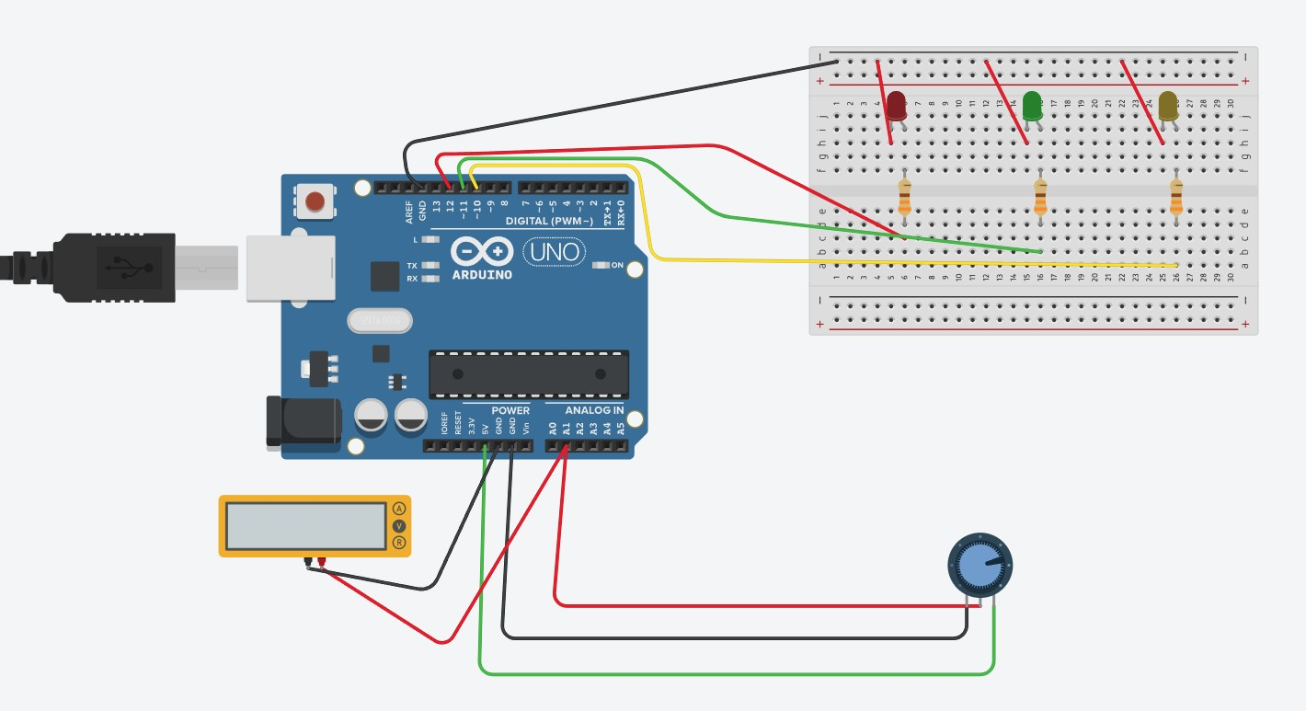Multimeter

Code:

int LED_RED=12; int LED_GREEN=11;

int LED_YELLOW=10;

void setup()

{

pinMode(LED_RED, OUTPUT);

pinMode(LED_GREEN, OUTPUT); pinMode(LED_YELLOW, OUTPUT);

pinMode(A1, INPUT);

Serial.begin(9600);

}

void loop()

{

float analogval=analogRead(A1); float volt= (5*analogval)/1023; Serial.println(volt);

delay(1000);

if(volt<3.3 && volt>=3){ digitalWrite(LED_RED,HIGH); digitalWrite(LED_GREEN,LOW); digitalWrite(LED_YELLOW,LOW);

}

else if(volt>=2 && volt <3){ digitalWrite(LED_RED,LOW); digitalWrite(LED_GREEN,LOW); digitalWrite(LED_YELLOW,HIGH);

}

else if(volt <2){ digitalWrite(LED_RED,LOW); digitalWrite(LED_GREEN,HIGH); digitalWrite(LED_YELLOW,LOW);

}

else{ digitalWrite(LED_RED,LOW); digitalWrite(LED_GREEN,LOW);

digitalWrite(LED_YELLOW,LOW);

}

}